**4. hyperparameter_for_mage**

**Hyperparameter tuning** [**getting_started**](https://scikit-learn.org/stable/getting_started.html) **&** [**model_persistence**](https://scikit-learn.org/stable/model_persistence.html)

* 1. **Vs Code**

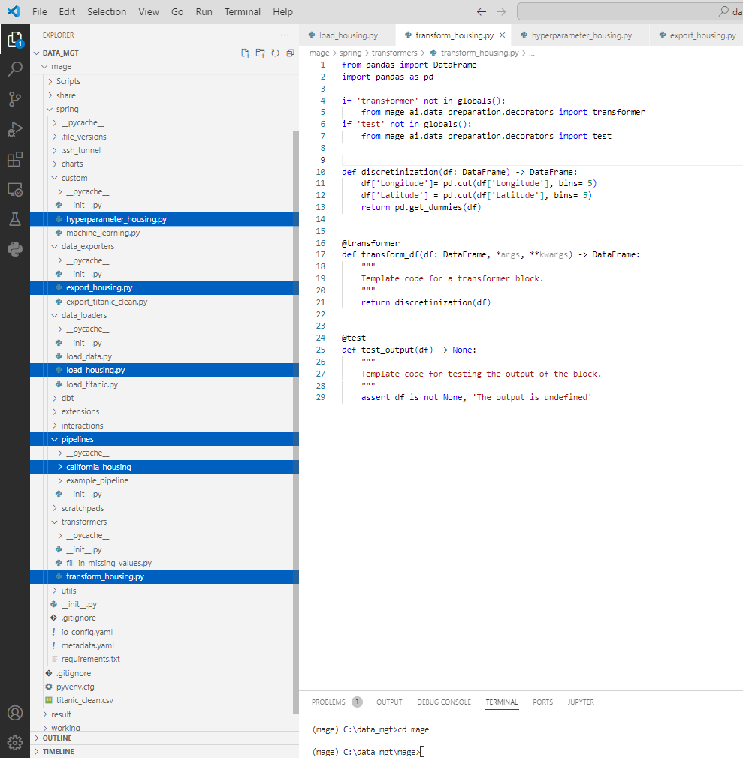

Dataloader block

from sklearn.datasets import fetch_california_housing

from pandas import DataFrame

import pandas as pd

if 'data_loader' not in globals():

    from mage_ai.data_preparation.decorators import data_loader

if 'test' not in globals():

    from mage_ai.data_preparation.decorators import test

print(fetch_california_housing().keys())

@data_loader

def load_data_from_api(**kwargs) -> DataFrame:

    X = pd.DataFrame(fetch_california_housing().data,

                 columns=fetch_california_housing().feature_names)

    y = pd.DataFrame(fetch_california_housing().target,

                 columns=fetch_california_housing().target_names)

    return pd.merge(X, y, left_index=True, right_index=True)

@test

def test_output(df) -> None:

    """

    Template code for testing the output of the block.

    """

    assert df is not None, 'The output is undefined'

Datatransformer block

from pandas import DataFrame

import pandas as pd

if 'transformer' not in globals():

    from mage_ai.data_preparation.decorators import transformer

if 'test' not in globals():

    from mage_ai.data_preparation.decorators import test

def discretinization(df: DataFrame) -> DataFrame:

    df['Longitude']= pd.cut(df['Longitude'], bins= 5)

    df['Latitude'] = pd.cut(df['Latitude'], bins= 5)

    return pd.get_dummies(df)

@transformer

def transform_df(df: DataFrame, *args, **kwargs) -> DataFrame:

    """

    Template code for a transformer block.

    """

    return discretinization(df)

@test

def test_output(df) -> None:

    """

    Template code for testing the output of the block.

    """

    assert df is not None, 'The output is undefined'

@custom

import pandas as pd

import os

import pickle

from sklearn.ensemble import RandomForestRegressor

from sklearn.model_selection import RandomizedSearchCV

from sklearn.model_selection import train_test_split

from scipy.stats import randint

if "custom" not in globals():

    from mage_ai.data_preparation.decorators import custom

if "test" not in globals():

    from mage_ai.data_preparation.decorators import test

def _model_save(rf_model):

    """

    Save RandomForest model to a file.

    """

    # Here you would implement the logic to save your trained model to a file

    # Example:

    os.makedirs('../result', exist_ok= True)

    with open('../result/random_forest_model.pkl', 'wb') as file:

        pickle.dump(rf_model, file)

    pass

@custom

def random_forest_train(df: pd.DataFrame, *args, **kwargs):

    """

    Train a Random Forest Classifier and predict the 'Survived' column.

    Args:

        df: Data frame containing the training data.

    Returns:

        Data frame with a new column 'Survived_predict' with predictions.

    """

    # Prepare the data

    X = df.drop(['MedHouseVal'], axis=1)

    y = df['MedHouseVal']

    X_train, X_test, y_train, y_test = train_test_split(X, y, random_state=0)

    # define the parameter space that will be searched over

    param_distributions = {'n_estimators': randint(1, 5),

                           'max_depth': randint(5, 10)}

    # now create a searchCV object and fit it to the data

    search = RandomizedSearchCV(estimator=RandomForestRegressor(random_state=0),

                                n_iter=10,

                                param_distributions=param_distributions,

                                random_state=0)

    # Initialize the Random Forest Classifier

    rf_model = RandomForestRegressor(random_state=0),

    # Train the model, now create a searchCV object and fit it to the data

    search = RandomizedSearchCV(estimator=RandomForestRegressor(random_state=0),

                                n_iter=10,

                                param_distributions=param_distributions,

                                random_state=0)

    search.fit(X_train, y_train)

    tf = pd.DataFrame(search.cv_results_)[['param_max_depth', 'param_n_estimators', 'params', 'mean_test_score', 'rank_test_score']]

    print(tf.sort_values('rank_test_score'))

    print(f"The Best model's parameters is {search.best_params_}")

    print(f'The Best accuracy score of model is {search.score(X_test, y_test)}')

    # Predict using the trained model

    y_pred = search.predict(X_test)

    # Optionally save the model

    _model_save(search)

    # Assign predictions to a new column in the dataframe

    tf = pd.merge(X_test, y_test, left_index=True, right_index=True)

    tf['Hosing_pred'] = y_pred

    return tf

@test

def test_output(output, *args) -> None:

    """

    Template code for testing the output of the block.

    Args:

        output: The output from the random_forest_train function.

    """

    assert output is not None, "The output is undefined"

    assert 'Survived_predict' in output.columns, "Prediction column is missing in the output dataframe"

    # You can add more tests to check the quality of your predictions,

    # such as accuracy score, confusion matrix, etc.

@data_exporter

from mage_ai.io.file import FileIO

from pandas import DataFrame

if 'data_exporter' not in globals():

    from mage_ai.data_preparation.decorators import data_exporter

@data_exporter

def export_data_to_file(df: DataFrame, **kwargs) -> None:

    filepath = '../result/housing_predict.csv'

    FileIO().export(df, filepath)

* 1. **Mage.ai WEB UI**
* (mage) C:\data_mgt\mage>mage start spring
* spring > Pipeline > click  > click pipeline name

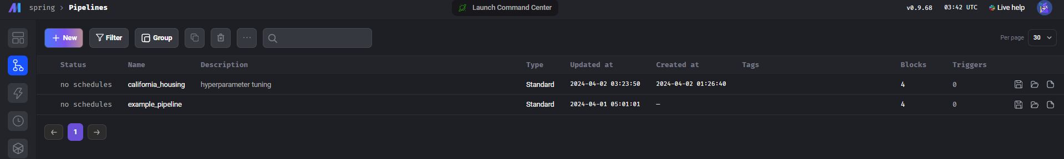

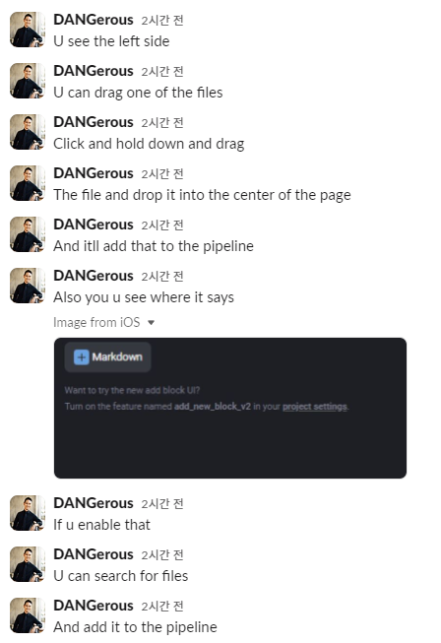

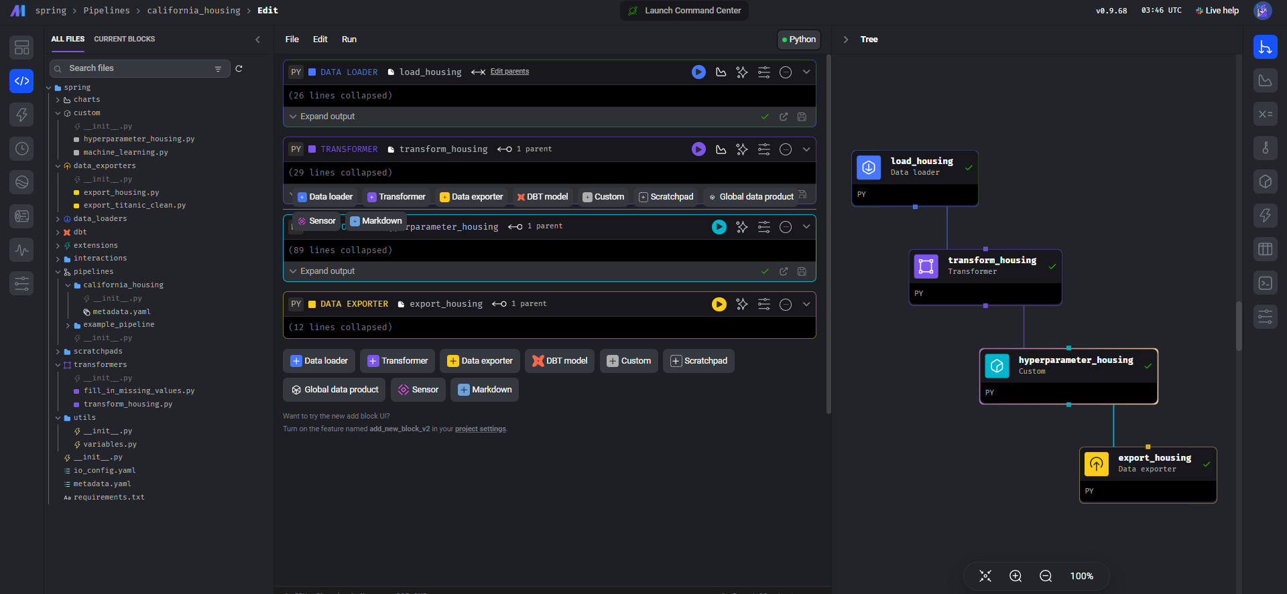

* **py파일을 편집하고 싶으면 VS code에서 편집하고 저장(ctrl + s),** **화면 reset**